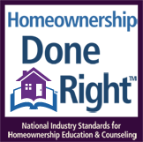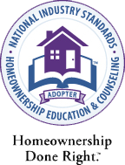

**Learn about:**

* Buying a home
* Managing your money
* Types of home loans
* What you can afford
* Mortgages
* Understanding your credit score

Free

**Homebuyer Education Class**

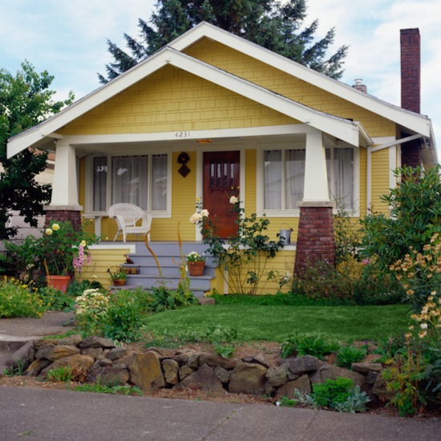

**Saturday, February 13, 2021**

**Saturday, May 15, 2021**

**Saturday, August 14, 2021**

**Saturday, November 13, 2021**

**9:00 am (Online)**

Class will be held online via Zoom meetings

To register for the class, please contact the R.I. Department at

724-287-6797

1-800-433-6327

**Thank you to our sponsors!**

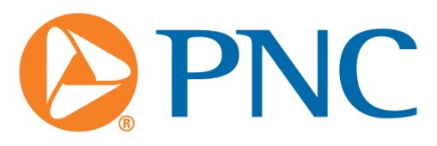[PNC Leading the Way](https://www.pnc.com/webapp/unsec/Gateway.do?siteArea=/PNC/Home/Gateway)



**Call today!**

Find answers to all your questions!

Homeownership is at your fingertips!

www.housingauthority.com